A MINI PROJECT REPORT ON
Movie Recommendation System using Content-Based Filtering and Quantum Similarity Classification“

Submitted by

Under the guidance of Mr. Narsing Kadam

Submitted in partial fulfilment for the award of the degree of
BACHELOR OF TECHNOLOGY (COMPUTER ENGINEERING)

DEPARTMENT OF COMPUTER ENGINEERING
G H RAISONI COLLEGE OF ENGINEERING AND MANAGEMENT, PUNE

(An Empowered Autonomous Institute, Affiliated to SAVITRIBAI PHULE PUNE UNIVERSITY )
2025-2026



CERTIFICATE
This is to certify that the work entitled

“Movie Recommendation System using Content-Based Filtering and Quantum Similarity Classification“

Submitted by

are a Bonafide students of this institute and the work has been carried out by them under the supervision of Mr. Narsing kadam and it is approved for the partial fulfillment of the requirement of an autonomous institute, affiliated to Savitribai Phule Pune University, for the award of the degree of Bachelor of Technology in Computer Engineering in the academic year 2025-2026.

Mr. Narsing Kadam Dr. Sarita Patil
(Guide) HoD (Computer Engineering)

Date:
Place: Pune

ACKNOWLEDGEMENT

We would like to express our heartfelt gratitude to all those who supported and guided us throughout the completion of this project. Their contributions, encouragement, and assistance have been vital to our success.
First and foremost, we extend our deepest gratitude to our project guide, Mr. Narsing Kadam, Assistant Professor, Department of Computer Engineering, for her exceptional guidance, continuous encouragement, and constant support. Her expertise, patience, and valuable insights have been instrumental in shaping the direction and outcome of this project. Without her dedicated involvement, completing this work in a timely manner would not have been possible.
We are also sincerely thankful to the B. Tech. Project Coordinators — Dr. Pushpi Rani for their continuous support, valuable feedback, and encouragement throughout the duration of our project. Their efforts helped us stay focused and motivated at every stage.
We are highly grateful to Dr. Sarita Patil, Head of the Department of Computer Engineering, for creating a research-conducive environment and for her encouragement and support, which played a key role in the successful completion of our project.
Last but not the least, we would like to thank Dr. N.B Hulle, Director, GHRCEM, Pune, for giving us the opportunity to pursue our TY B. Tech. from this esteemed institution. His vision, leadership, and motivation have been a guiding force throughout our academic journey.
Finally, we express our heartfelt appreciation to our families and friends for their constant encouragement, support, and understanding. Their presence and best wishes have been a source of strength throughout this endeavor.

Abstract

This project presents a simple and efficient Movie Recommendation System developed using content-based filtering techniques. The system takes three movie names as input from the user and recommends similar movies based on features such as genre, director, release year, keywords, and rating.
The recommendation engine uses cosine similarity to compare movie feature vectors and identify the most relevant suggestions. A CSV dataset is used to store movie information, and the system processes this data to generate personalized recommendations.
The project is implemented using Python, Pandas, Scikit-learn, and Streamlit, providing a clean and user-friendly web interface. The system aims to help users discover movies that match their preferences in a simple and effective way.
This project demonstrates the practical use of machine learning concepts in recommendation systems and serves as a useful mini-project in the field of intelligent systems and web-based applications.

Contents

- Introduction 3
  - Project Idea . . . . . . . . . . . . . . . . . . . . . . . . . . . . . . 3
  - Motivation of the Project . . . . . . . . . . . . . . . . . . . . . . . 3
  - Literature Survey . . . . . . . . . . . . . . . . . . . . . . . . . . . 3
- Problem Definition and scope 4
  - Problem Statement . . . . . . . . . . . . . . . . . . . . . . . . . . 4
    - Goals and objectives . . . . . . . . . . . . . . . . . . . . . 4
    - Statement of scope . . . . . . . . . . . . . . . . . . . . . . 4
  - Major Constraints . . . . . . . . . . . . . . . . . . . . . . . . . . . 4
  - Methodologies of Problem solving and efficiency issues . . . . . . . 4
  - Outcome . . . . . . . . . . . . . . . . . . . . . . . . . . . . . . . . 5
  - Applications . . . . . . . . . . . . . . . . . . . . . . . . . . . . . . 5
  - Hardware Resources Required . . . . . . . . . . . . . . . . . . . . 5
  - Software Resources Required . . . . . . . . . . . . . . . . . . . . . 5
- Project Plan 6
  - Project Estimates . . . . . . . . . . . . . . . . . . . . . . . . . . . 6
    - Reconciled Estimates . . . . . . . . . . . . . . . . . . . . . 6
    - Project Resources . . . . . . . . . . . . . . . . . . . . . . . 6
  - Risk Management w.r.t. NP Hard analysis . . . . . . . . . . . . . . 6
    - Risk Identification . . . . . . . . . . . . . . . . . . . . . . 6
    - Risk Analysis . . . . . . . . . . . . . . . . . . . . . . . . . 7
    - Overview of Risk Mitigation, Monitoring, Management . . 7
  - Project Schedule . . . . . . . . . . . . . . . . . . . . . . . . . . . 9
    - Project task set . . . . . . . . . . . . . . . . . . . . . . . . 9
    - Task network . . . . . . . . . . . . . . . . . . . . . . . . . 9
    - Timeline Chart . . . . . . . . . . . . . . . . . . . . . . . . 9
  - Team Organization . . . . . . . . . . . . . . . . . . . . . . . . . . 9
    - Team structure 10
    - Management reporting and communication . . . . . . . . . 10
- Software requirement specification 11
  - Introduction 11
    - Purpose and Scope of Document . . . . . . . . . . . . . . . 11
    - Overview of responsibilities of Developer . . . . . . . . . . 11
  - Usage Scenario 11
    - User profiles 11
    - Use-cases 11
    - Use Case View 12
  - Data Model and Description 12
    - Data Description 12
    - Data objects and Relationships . . . . . . . . . . . . . . . . 13
  - Functional Model and Description 13
    - Data Flow Diagram 13
    - Activity Diagram: 13
    - Non Functional Requirements: . . . . . . . . . . . . . . . . 13
    - State Diagram: 13
    - Design Constraints . . . . . . . . . . . . . . . . . . . . . . 14
    - Software Interface Description . . . . . . . . . . . . . . . . 14
- Detailed Design Document 15
  - Introduction 15
  - Architectural Design 15
  - Data design 15
    - Internal software data structure . . . . . . . . . . . . . . . . 15
    - Global data structure . . . . . . . . . . . . . . . . . . . . . 15
    - Temporary data structure . . . . . . . . . . . . . . . . . . . 15
    - Database description 17
    - Class Diagram 17

8 Project Implementation |  | 18
8.1 Introduction |  | 18
8.2 Tools and Technologies Used |  | 18
8.3 Methodologies/Algorithm Details |  | 18
8.3.1 Algorithm 1/Pseudo Code |  | 18
8.3.2 Algorithm 2/Pseudo Code |  | 18
8.4 Verification and Validation for Acceptance |  | 18
9 Software Testing |  | 19
9.1 Type of Testing Used |  | 19
9.2 Test Cases and Test Results |  | 19
10 | Results and Discussion | 20
 | 10.1 Screen shots | 20
 | 10.2 Outputs | 20
11 | Deployment and Maintenance | 21
 | 11.1 Installation and un-installation | 21
 | 11.2 User help | 21
12 | Conclusion and Future Scope | 22
 | 12.1 Conclusion | 22
 | 12.2 Future Scope | 22
A | References | 23

Introduction

Overview
The Movie Recommendation System is a simple web-based application developed to suggest movies to users based on their preferences. The system takes three movie names as input from the user and recommends top five similar movies using a content-based filtering approach.
The recommendation process is based on movie features such as genre, director, keywords, release year, and ratings. By using similarity measures, the system identifies movies that closely match the user’s interests and displays personalized recommendations.
The project is implemented using Python, Pandas, Scikit-learn, and Streamlit, making it easy to use and efficient for practical demonstration.

Motivation
In today’s digital environment, organizations and individuals frequently exchange sensitive documents online. However, this growing reliance on network-based sharing brings serious risks including data breaches, unauthorized access, and document tampering. Incidents of forged or intercepted documents have emphasized the urgent need for secure and verifiable document exchange systems.
With the rapid growth of digital entertainment platforms, users are often overwhelmed by the large number of available movie choices. Finding movies that match personal preferences can be time-consuming and difficult.
The motivation behind this project is to develop a simple and intelligent recommendation system that helps users quickly discover movies similar to the ones they already enjoy. Inspired by platforms such as Netflix and Amazon Prime, this project aims to demonstrate how machine learning concepts can be applied to provide personalized user experiences.
Through this approach, the project aims to address the key challenges of secure document sharing authentication, authorization, and integrity verification while leveraging modern web technologies and security standards.

Project Scope
The scope of this project is limited to a content-based movie recommendation system. The system focuses on recommending movies by analysing their features and comparing them with the movies entered by the user.
The project includes:
- taking movie names as user input
- processing movie data from a CSV dataset
- calculating similarity scores
- displaying top recommended movies
The system is designed as a mini-project for academic purposes and can be extended in the future with user ratings, collaborative filtering, and larger datasets.

1.5 Objectives of the Study
The main objective of this study is to design and develop a secure digital document exchange system that protects sensitive files from unauthorized access using modern authentication techniques. The system aims to overcome the limitations of traditional methods like passwords and email sharing by integrating QR codes, One-Time Passwords (OTP), and controlled access mechanisms.
Key objectives include:
- To generate secure, time-limited QR codes for each shared document so that the access link expires automatically and reduces misuse.
- To implement OTP-based 2-Factor Authentication, ensuring that only the intended recipient who receives the OTP via email/phone can open the document.

- To develop a simple movie recommendation system
- To accept three movie names as input from the user
- To recommend top five similar movies
- To implement content-based filtering using cosine similarity
- To provide a simple and user-friendly web interface
- To demonstrate the practical application of machine learning concepts in recommendation systems

Software Requirement Specification (SRS)

The Software Requirement Specification defines the complete functional and non-functional requirements of the Movie Recommendation System. This chapter explains how the system operates, its assumptions, dependencies, and the features required for smooth recommendation of movies.

System Overview and Development Architecture
The proposed system provides a simple and user-friendly platform for recommending movies based on user preferences.
The system takes three movie names as input from the user and recommends top five similar movies using a content-based filtering approach.
The architecture of the system includes:

Frontend:
• Built using Python
• Handles feature extraction, similarity calculation, and recommendation logicDatabase:

Dataset
- Uses a CSV file containing movie details such as:
  - movie name
  - genre
  - director
  - keywords
  - year
  - rating

Machine Learning Components Used
- Pandas for data processing
- Scikit-learn for vectorization and cosine similarity
- NumPy for numerical operations

High-Level Flow:

- User enters 3 movie names
- System searches the dataset
- Features of the movies are extracted
- Similarity score is calculated
- Top 5 similar movies are recommended
- Results are displayed on screen

Assumptions and Dependencies
Assumptions
The system is developed under the following assumptions:
- User enters valid movie names
- The dataset contains the entered movies
- The system runs in a stable Python environment
- The dataset is properly formatted
- Internet is available if deployed online

Dependencies
The system depends on:
- Python 3.x
- Pandas
- NumPy
- Scikit-learn
- Streamlit
- CSV dataset
- Modern web browser

System Dependencies
These dependencies come directly from the uploaded architecture files: Backend Dependencies
- Python
- Pandas
- NumPy
- Scikit-learn
These dependencies make the system cryptographically strong, stable, and scalable.

Used for:
- data preprocessing
- vectorization
- similarity calculation
- recommendation generation
Frontend Dependencies
- Streamlit
Used for:
- user input
- displaying recommendations
- interactive interface
Dataset Dependency
- CSV file containing movie information
These dependencies make the system simple, scalable, and easy to maintain.

Functional Requirements
Functional requirements describe what the system must do. Based on the documents, the core functionality includes:
The core functionalities include:
1. User Input
- User must enter 3 movie names
- Input validation must be performed
2. Dataset Search
- System searches for entered movies in dataset
- Invalid movie names should show an error
3. Feature Extraction
- Extract genre, keywords, director, year, and rating
4. Similarity Calculation
- Use cosine similarity to compare movies
5. Recommendation Output
- Display top 5 recommended movies
6. Error Handling
- Handle invalid inputs
- Handle missing movies

Non-Functional Requirements
These describe the quality attributes of the system:
- Security
  - AES-256 encryption ensures document confidentiality.
  - JWT tokens prevent tampering.
  - OTP ensures dynamic user authentication.
  - Secure HTTPS communication must be enforced.
- Performance
  - QR decoding should be instant (<200 ms).
  - OTP delivery should be within a few seconds.
  - Dashboard must load quickly even with multiple documents.
- Scalability
  - System must support increased number of users and documents.
  - Database should efficiently handle large encrypted files.
- Reliability
  - OTP generation and email services must have high availability.
  - Access should not fail under normal load.
- Usability
  - Interface must be clean, intuitive, and beginner-friendly.
  - Users should easily upload, share, scan, and access documents.
  - Instructions should be clear at every step.
- Compatibility
  - QR scanning must work on all modern devices (Android/iOS/Web).
  - System should run smoothly across major browsers.
- Maintainability
  - Code should follow modular architecture (frontend + backend separation).
  - APIs must be documented and easy to update.

- Audit & Traceability
  - Access logs should be stored securely and viewable by admin.
  - All actions must have timestamps for compliance.

- System Design

The system design describes how the “Secure Document Sharing Using QR and OTP” platform is structured, how users interact with the modules, and how documents move securely from upload to access. The design focuses on combining QR code authentication, OTP-based verification, and encrypted document storage to ensure confidentiality, integrity, and traceability of shared files.

System Architecture Overview
The overall architecture of the system integrates three major components:
    - Frontend Interface (User Interaction Layer)
    - Backend Server (Processing & Security Layer)
    - Database System (Storage & Validation Layer)
The frontend provides a simple and interactive interface where users can enter three movie names and receive recommendations.
The backend handles:

- input validation
- feature extraction
- similarity calculation
- recommendation generation

The dataset layer stores movie-related information such as:

- movie name
- genre
- director
- release year
- rating
- keywords

The system follows a simple recommendation workflow ensuring that:
- user input is validated
- movie features are processed
- similarity is calculated
- top matching movies are displayed

4.2 System Components and Modules
The system is composed of several interconnected modules that work together to enable secure document sharing.
The system is composed of the following modules:
1. User Input Module
This module accepts three movie names from the user through the web interface.
It validates:
- empty inputs
- duplicate entries
- invalid movie names

2. Dataset Management Module
This module loads and manages the movie dataset from the CSV file.
It is responsible for:
- reading the dataset
- preprocessing movie information
- handling missing values

3. Feature Extraction Module
This module extracts important features such as:
- genre
- director
- keywords
- release year
- rating
These features are combined into a unified vector representation.

4. Recommendation Engine Module
This is the core module of the system.
It performs:
- vectorization
- cosine similarity calculation
- ranking of movies
- top 5 recommendation generation

5. Output Display Module
This module displays the recommended movies in a user-friendly format on the interface.

3.3 Workflow of Movie Recommendation System
The workflow of the system is as follows:
Step 1: User Input
The user enters three movie names.

Step 2: Input Validation
The system checks whether the entered movie names exist in the dataset.

Step 3: Feature Extraction
The system extracts features of the selected movies.

Step 4: Similarity Calculation
Cosine similarity is calculated between the selected movies and all other movies in the dataset.
[
Similarity = \frac{A \cdot B}{|A||B|}
]

Step 5: Recommendation Generation
The system selects the top 5 most similar movies.

Step 6: Output
Recommended movies are displayed to the user.

Data Flow Diagram (DFD) Description
Below is a humanized written explanation of the Data Flow, based on your system design.
Level 0: Context Flow
The user interacts with the system by entering movie names.
The system processes the input and returns recommended movies.

Level 1: Detailed Data Flow
1. Input Flow
- user enters 3 movie names
- input sent to validation module
2. Process Flow
- dataset search
- feature extraction
- similarity calculation
- ranking
3. Output Flow
- top 5 recommended movies displayed
4. Storage Flow
- movie dataset stored in CSV file
- processed vectors stored temporarily during execution
  - Data Flow Diagram (DFD): We provide a sample DFD illustrating user authentication and document flow.
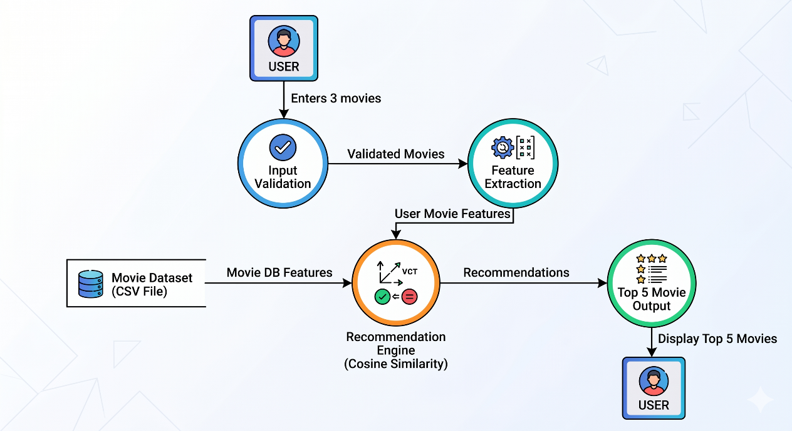

Figure 1: Sample Data Flow Diagram (DFD) of the system.

    - System Design

- Phase 4: Testing and debugging – 3 Weeks
Conducting unit testing, integration testing, and validation of security features like OTP and QR-based access.
- Phase 5: Documentation and Final Report Preparation.

Total Duration:
The project was completed within the planned semester duration, ensuring proper balance between academic schedules and project milestones.

Cost Estimate
Since the system was developed entirely using open-source technologies, the financial cost involved was minimal. The tools, libraries, and databases used are free, which makes the system cost-effective and practical for academic and small-scale use. The project demonstrates that efficient system development can be achieved with minimal cost using open-source platforms and cloud-based tools.

Manpower Estimate
The project was developed by a team of two members working collaboratively throughout the semester. Both team members were equally involved in system design, coding, testing, and documentation.
Each member contributed around 60 to 70 working hours, leading to a combined total of approximately 120 to 140 working hours of effective effort across the semester.
This teamwork approach ensured faster development, better problem-solving, and timely completion of the project milestones.

Resource Estimate
The resources required for the project include both software and hardware components necessary for design, development, and testing.

Software Resources Used:
    - Operating System: Windows 10 or Linux
    - Development Tools: Visual Studio Code
    - Backend: Node.js with Express.js
    - Frontend: React + Vite (HTML, CSS, JavaScript)

    - Database: PostgreSQL
    - APIs and Libraries: Gmail HTTP API, QR Code Generator, AES Encryption, bcrypt, and JSON Web Token
    - Browser: Google Chrome or Microsoft Edge

Hardware Resources Used:
    - Processor: Intel Core i3 or higher
    - RAM: 4 GB minimum (8 GB recommended)
    - Storage: 20 GB free space

5. Project Implementation
The Movie Recommendation System is implemented using a simple and modular approach to ensure easy understanding, scalability, and maintainability.
The project is developed using Python, Pandas, Scikit-learn, and Streamlit.
The implementation includes the following steps:
- Dataset Loading:
The movie dataset is loaded from a CSV file using Pandas.
- Data Preprocessing:
Important features such as genre, director, keywords, year, and rating are cleaned and combined into a single feature column.
- Vectorization:
The combined movie features are converted into numerical vectors for similarity calculation.
- Similarity Calculation:
Cosine similarity is used to compare the selected movies with all movies in the dataset.
[
Similarity = \frac{A \cdot B}{|A||B|}
]
- Recommendation Generation:
The top 5 most similar movies are selected and displayed.
- Frontend Implementation:
Streamlit is used to build a simple web interface where the user enters 3 movie names and receives recommendations.
- Error Handling:
Invalid movie names and empty inputs are properly handled.

5.1 Overview of Project Modules
The Movie Recommendation System is designed using a modular approach.
Each module is responsible for a specific functionality, and all modules work together to provide personalized movie suggestions.
The system is divided into the following main modules:

1. User Input Module
This module handles user interaction.
The user enters three movie names through the web interface.
Key Features:
- accepts movie names
- validates empty inputs
- prevents duplicate inputs
- checks movie availability

2. Dataset Management Module
This module manages the movie dataset.
The dataset is stored in CSV format and contains:
- movie name
- genre
- director
- year
- rating
- keywords
Key Features:
- load dataset
- clean data
- handle missing values
- manage movie records

3. Feature Extraction Module
This module extracts important features from the dataset.
Features used include:
- genre
- director
- keywords
- rating
- release year
These features are combined into a single representation.
Key Features:
- feature selection
- feature combination
- preprocessing

4. Similarity Calculation Module
This is the core recommendation engine.
It uses cosine similarity to compare movies.
[
Similarity = \frac{A \cdot B}{|A||B|}
]
Key Features:
- vectorization
- similarity score calculation
- ranking movies

5. Recommendation Output Module
This module generates the final recommendations.
It selects the top 5 most similar movies.
Key Features:
- rank recommendations
- remove duplicate movies
- display results

6. User Interface Module
This module is implemented using Streamlit.
It provides:
- clean UI
- input fields
- recommendation button
- result display
Key Features:
- simple interface
- user-friendly design
- responsive layout

7. Database / File Management Module
This module manages the CSV dataset and any additional files.
Key Features:
- dataset storage
- file reading
- future scalability support

6. Results

6.1 Overview
The Movie Recommendation System project was successfully designed, developed, and tested.
The system allows users to enter three movie names and generates top five similar movie recommendations based on content-based filtering and cosine similarity.
The system provides fast and relevant recommendations using movie features such as genre, director, keywords, release year, and ratings.

6.2 System Implementation Results
The project was implemented using the following setup:
- Frontend: Streamlit
- Backend: Python
- Libraries: Pandas, NumPy, Scikit-learn
- Dataset: CSV file containing movie details
All components work together to handle user input, feature extraction, similarity calculation, and recommendation generation.

6.3 Output Explanation

a. User Input and Validation
- The user enters three movie names
- The system validates whether the movies exist in the dataset
- Invalid or empty inputs generate an error message
Output:
The system successfully validates movie names and proceeds to recommendation generation.

b. Dataset Processing
- The movie dataset is loaded from the CSV file
- Important features such as genre, director, and keywords are extracted
- Data is cleaned and preprocessed
Output:
Movie data is successfully loaded and prepared for similarity calculation.

c. Similarity Calculation
- The system uses cosine similarity
- Feature vectors of selected movies are compared with all movies in the dataset
[
Similarity = \frac{A \cdot B}{|A||B|}
]
Output:
Similarity scores are calculated successfully for all movies.

d. Recommendation Generation
- The top 5 most similar movies are selected
- Duplicate recommendations are removed
- Movies already entered by the user are excluded
Output:
Top 5 recommended movies are displayed on the screen.
Example output:
- The Prestige
- Interstellar
- Blade Runner 2049
- Arrival
- Ex Machina

e. User Interface Display
- Recommendations are displayed using Streamlit
- Clean and user-friendly output format
- Easy to use interface
Output:
Recommended movies are shown instantly after clicking the Recommend Movies button.

Screenshots:



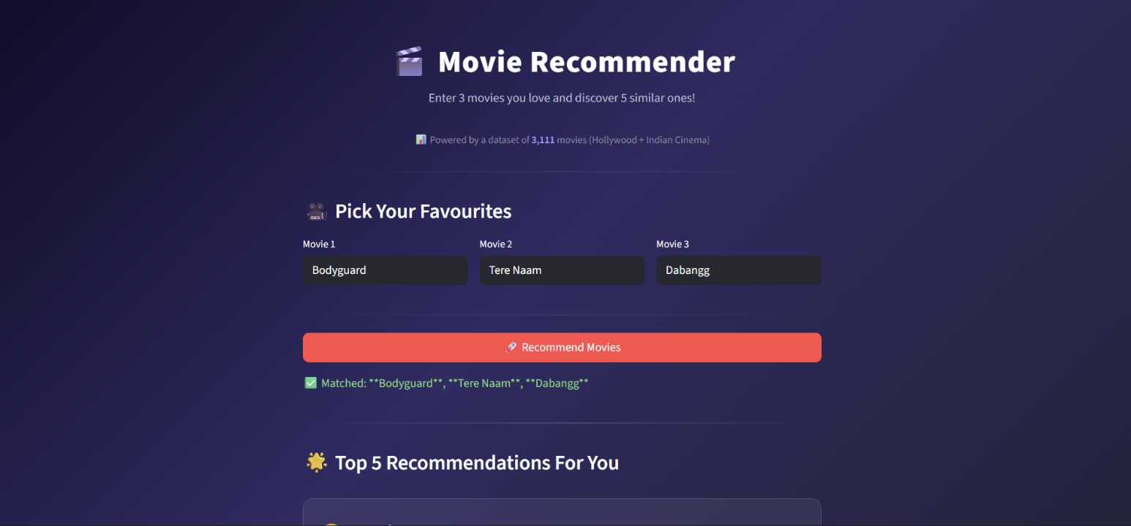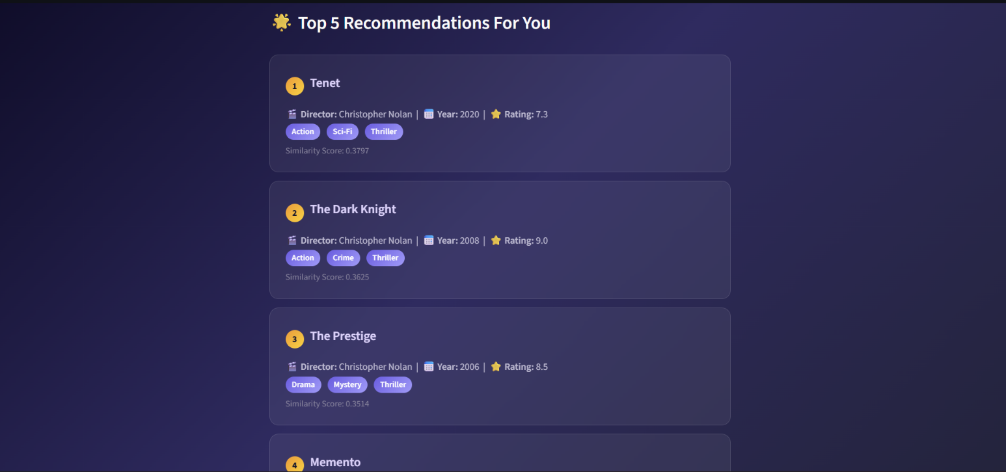

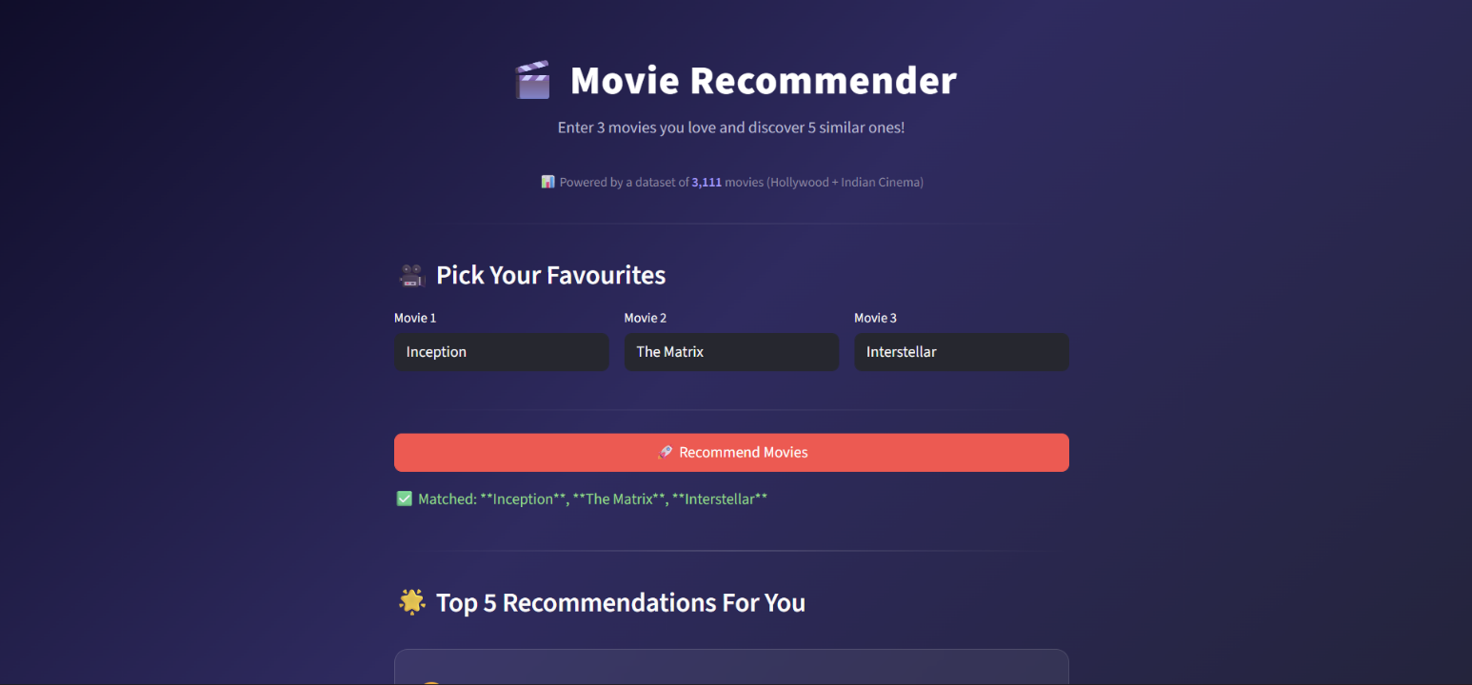

Conclusion

7. Conclusion
This project demonstrates a simple and effective approach for personalized movie recommendations using content-based filtering.
By taking three movie names as input from the user and analyzing movie features such as genre, director, keywords, release year, and ratings, the system successfully recommends top five similar movies.
The implementation using Python, Pandas, Scikit-learn, and Streamlit provides a practical and user-friendly solution for recommending movies based on user preferences.
The use of cosine similarity ensures that recommendations are relevant and generated efficiently.
Overall, this project serves as a useful academic mini-project that demonstrates the practical application of machine learning concepts in recommendation systems.

8. Future Work
Although the current system successfully provides a simple and efficient movie recommendation mechanism, there is still scope for further enhancement in future versions.
In future work, the system can be expanded to include:
- user-based collaborative filtering
- ratings-based recommendations
- genre-wise filtering
- actor and director-based suggestions
- larger movie datasets
- web deployment on cloud platforms
A mobile application version can also be developed for Android and iOS platforms.
Additionally, advanced machine learning models and deep learning-based recommendation systems can be integrated to improve accuracy and personalization.

References

- Suhartana, I. K. G., Suputra, I. N. B., Gunawan, A. A. N. G. , “Securing OTP-Based Access in Film-Sharing Platforms Using RSA Encryption and QR Codes” 2023.
- Rana, M., Khokale, R., Makesar, M. S., Kakde, V. A., Shende, A. A.,“Remote File Sharing System for Education Institution”International Journal of Research, 2021.

- Nor, F. M., Aziz, S. N. A., Zulkifli, N. A., Nordin, N. A., Yunus, N. S. M, “Laboratory Access Implementing QR Code,” International Journal of Computing and Informatics (IJCI),2020.
- Patil, V., Katkar, C., Rahate, R., Waykar, S. , “QR Code Document Authentication and Retrieval. Institutional Project Report” MGMCET Kamothe,2024.
- Ataelfadiel, M. A. M, “Enhancing Digital Security: A QR Code and OTP-Based E- Authentication System” King Faisal University Research Publication. Available upon request from university repository,2023.
- Madhushree, B., Manimegalai, M., Malini, G., “Securing E-Medical Documents Using QR Code,” R.M.K. Engineering College Research Journal. Available upon request or from institutional archive,2022.
- Valisireddy, J., Reddy, K. A., Elumalai, R., Mohan, L. N., Anjaneyulu, G. S. G. N,‘Secured Authentication of Online Documents Using Visual Secret Sharing on QR Code,” International Conference on Computing Technologies. Conference Proceedings,2021.
- Balaji, S., Pughazendi, N., Praveenkumar, S. E., Vishal, V., Vignesh, R. , “E-Medical Application using QR Code with OTP Generation,” . Institutional Project Report – Panimalar Engineering College,2022.
- Inder Pal Singh Sethi, Om Pradyumana Gupta, Sulbha Bhaisare, Ritesh Kumar Dwivedi, Misha Kapoor. ,“An introduction to using QR codes in web portals for synchronizing calendar events over phones” . IAES International Journal of Robotics and Automation, Vol. 13, No. 4, pp. 469–475,2024.
- M. Bartłomiejczyk,I. fray ,“Device risk analysis protocol for SMS-based OTP Authentication” ,DOI:10.1109/ACCESS.2024.3445931.

